The Nautilus DevOps team is tasked with deploying a containerized application using Amazon's container services. They need to create a private Amazon Elastic Container Registry (ECR) to store their Docker images and use Amazon Elastic Container Service (ECS) to deploy the application. The process involves building a Docker image from a given Dockerfile, pushing it to the ECR, and then setting up an ECS cluster to run the application.
- Create a Private ECR Repository:
  - Create a private ECR repository named devops-ecr to store Docker images.
- Build and Push Docker Image:
  - Use the Dockerfile located at /root/pyapp on the aws-client host.
  - Build a Docker image using this Dockerfile.
  - Tag the image with latest tag.
  - Push the Docker image to the devops-ecr repository.
- Create and Configure ECS cluster:
  - Create an ECS cluster named devops-cluster using the Fargate launch type.
- Create an ECS Task Definition:
  - Define a task named devops-taskdefinition using the Docker image from the devops-ecr ECR repository.
  - Specify necessary CPU and memory resources.
- Deploy the Application Using ECS Service:
  - Create a service named devops-service on the devops-cluster to run the task.
  - Ensure the service runs at least one task.

Use below given AWS Credentials: (You can run the showcreds command on aws-client host to retrieve these credentials)
Console URL | https://081866666028.signin.aws.amazon.com/console?region=us-east-1
Username | kk_labs_user_144632
Password | j6Vvyj@KWYrZ
Start Time | Mon Jan 12 13:10:17 UTC 2026
End Time | Mon Jan 12 14:10:17 UTC 2026
Notes:
- Create the resources only in us-east-1 region.
- To display or hide the terminal of the AWS client machine, you can use the expand toggle button as shown below:
Solutions:-
Run on AWS CLI console
~ on ☁️ (us-east-1) ➜ cd pyapp/

~/pyapp on ☁️ (us-east-1) ➜ ls
Dockerfile index.html

~/pyapp on ☁️ (us-east-1) ➜ docker build -t 240365323441.dkr.ecr.us-east-1.amazonaws.com/xfusion-ecr .
Successfully built 2bc6a8731084
Successfully tagged 240365323441.dkr.ecr.us-east-1.amazonaws.com/xfusion-ecr:latest

~/pyapp on ☁️ (us-east-1) ➜ docker images
REPOSITORY TAG IMAGE ID CREATED SIZE
240365323441.dkr.ecr.us-east-1.amazonaws.com/xfusion-ecr latest 2bc6a8731084 34 seconds ago 61.9MB
nginx alpine b9d44994d8ad 2 days ago 61.9MB

~/pyapp on ☁️ (us-east-1) ➜ aws ecr get-login-password | docker login --username AWS --password-stdin 240365323441.dkr.ecr.us-east-1.amazonaws.com
WARNING! Your password will be stored unencrypted in /root/.docker/config.json.
Configure a credential helper to remove this warning. See
https://docs.docker.com/engine/reference/commandline/login/#credentials-store

Login Succeeded

~/pyapp on ☁️ (us-east-1) ➜ docker push 240365323441.dkr.ecr.us-east-1.amazonaws.com/xfusion-ecr

latest: digest: sha256:9324ac5605d1c8d23171a2d4c80d42de544b25389daf14640bc38c0a0413f8bf size: 2196

🗂 Navigate to ECR
- Go to Services → Elastic Container Registry (ECR).
- You should create the repository devops-ecr.
Navigate to ECS
- Go to Services → Elastic Container Service (ECS).
- Create Clusters → devops-cluster.
Task Definition
- In ECS → Task Definitions, create for devops-taskdefinition.
- Confirm CPU = 5 /memory = 1 settings and container image reference (devops-ecr:latest).

Step 1: Create a Private ECR Repository
- Log in to the AWS Console using the provided URL and credentials.
- Navigate to Amazon ECR → Repositories.
- Click Create repository.
  - Name: devops-ecr
  - Visibility: Private
  - Region: us-east-1
- Click Create repository.

⚙️ Step 3: Create ECS Cluster
- In AWS Console → Amazon ECS → Clusters.
- Click Create cluster.
  - Name: devops-cluster
  - Launch type: Fargate
  - Region: us-east-1
- Click Create.
Step 4: Create ECS Task Definition
- Go to Task Definitions → Create new task definition.
- Choose Fargate.
- Name: devops-taskdefinition.
- Container definition:
  - Image: 081866666028.dkr.ecr.us-east-1.amazonaws.com/devops-ecr:latest
  - CPU: e.g., 256
  - Memory: e.g., 512
  - Port mappings: (if your app exposes a port, e.g., 8080 → 8080)
- Save and create the task definition.
Step 5: Deploy ECS Service
- Go to Clusters → devops-cluster.
- Click Create service.
  - Launch type: Fargate
  - Task definition: devops-taskdefinition
  - Service name: devops-service
  - Desired tasks: 1
- Configure networking (VPC, subnets, security groups).
- Click Create service.
Verification
- Go to Clusters → devops-cluster → Services.
- Ensure devops-service is running at least one task.
- Check Logs or CloudWatch to verify the container is running correctly.
- Amazon Elastic Container Service
- Clusters
- xfusion-cluster
- Tasks
- 4b69535a100845dcbd51a8ffe528664e
- Configuration

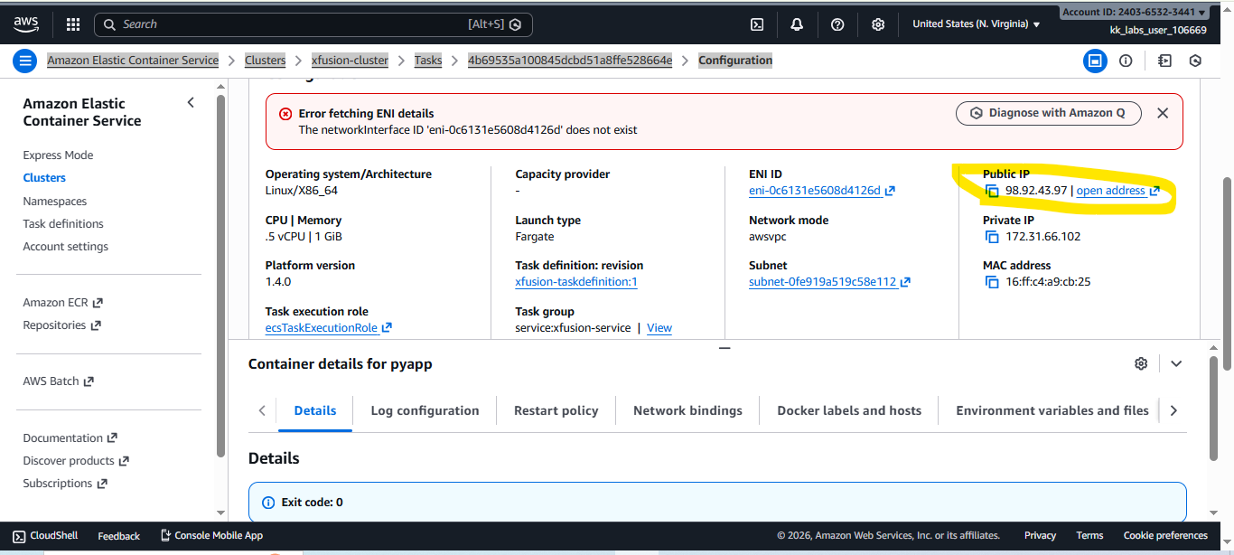
- Public IP
- 98.92.43.97 | open address

